Order Of Service

Singing: Psalm 96—CW page 102

Reading: Psalm 143

Opening Hymn: TLH 61

Reading: I Peter 2:11-25

Request Hymn: CW Supplement 702

Reading: Luke 21:25-38

Sermon Hymn: TLH 62

Sermon Text: Song Of Solomon 2:8

Behold, He Cometh !!!

Prayer

The Apostles’ Creed, TLH page 12

Holy Communion

The Lord's Prayer

The Blessing

Closing Hymn: TLH 64

* * * * * * * * * * *

Bible Study: Lambs: Joshua 6:1-5, 10- 20; Obey God
Sheep: Proverbs 7:1-9


Snow Geese—Heading South

Water
Of
Life

20 December 2015

W A T E R O F L I F E

Independent Christian Church—Conservative Lutheran Doctrine

Worship Service: 9:30 a.m. Bible Study: 10:45 a.m.

Larry Cooper, Pastor E-Mail address:
111 N. Ridge Road lcooper@wateroflife.cc
Coon Valley, WI 54623 Web Site:
Phone: (608) 452-2105 www.wateroflife.cc

* * * * * * * * * * * * * * * * * * * * * * * * * * *

Sermon Text: Song Of Solomon 2:8

Behold, He Cometh !!!

* * * * * * * * * * * * * * * * * * * * * * * * * * *

Song of Solomon 2:8 The voice of my beloved! behold, he cometh leaping upon the mountains, skipping upon the hills.

The first time we hear the word “voice” mentioned in Holy Scripture is in Genesis 3:8. “And they heard the voice of the LORD God walking in the garden in the cool of the day: and Adam and his wife hid themselves from the presence of the LORD God amongst the trees of the garden.” Adam and Eve were the ones who heard this voice, and they were terrified of it.
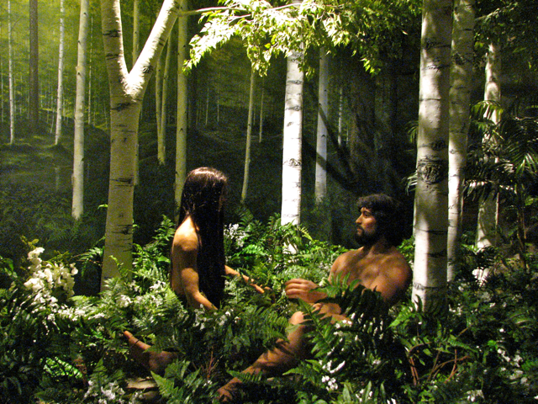

But now what a change has taken place! Here in Song Of Solomon 2:8 the Bride cries out—“The voice of my beloved!” And then in joy she exclaims—“Behold, He cometh!!!”

There is, of course, a reason for the change in heart on the part of the Bride.

Back in Eden’s Garden the Lord God had promised to send The Seed, born of a woman. And that Seed would crush the head of the Serpent. After a wait of some 4,000 years the Seed had come, the battle had taken place, and the victory had been won. Now the promise was about to come to completion—“For this purpose the Son of God was manifested, that he might destroy the works of the devil.”

The sins of the Bride have been forgiven by the blood of her Beloved. And now the marriage is about to take place.

In Revelation 22 the Bridegroom had promised—“Behold, I come quickly!” Now the Bride hears his voice, and shouts out—“Behold, He cometh!!!” And the wedding bells will ring!

